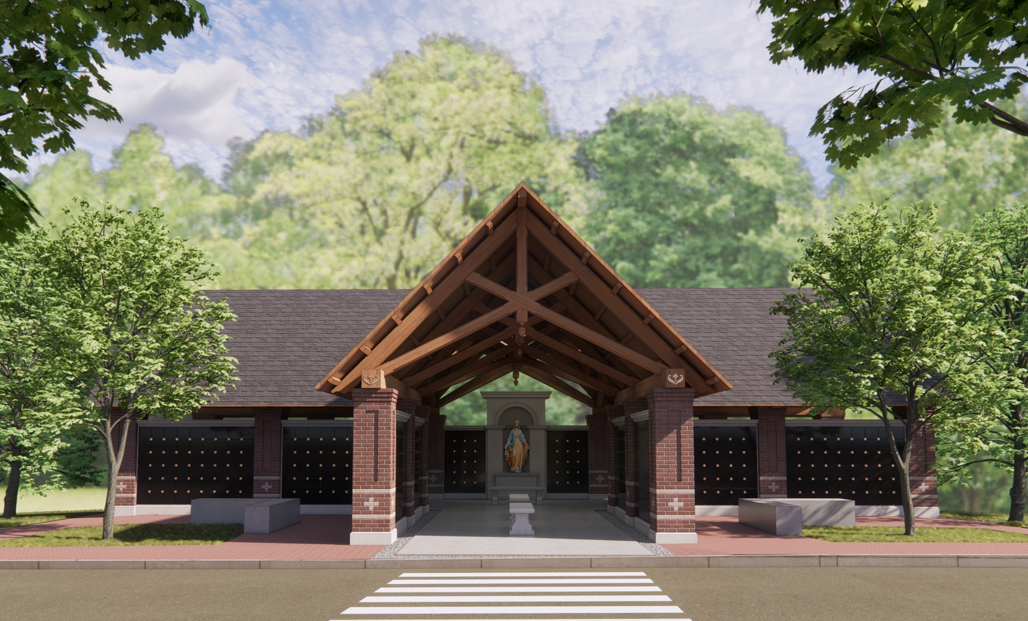

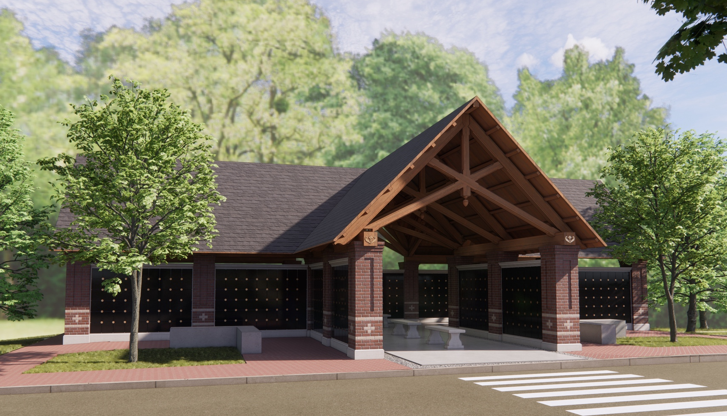

Mother Seton Columbarium
at St. Elizabeth Ann Seton Catholic Church
12807 Valleywood Drive, Lake Ridge, Virginia 22192

INFORMATION PACKET
March 4, 2025

Columbarium Eligibility. The Mother Seton Columbarium provides a sacred final resting place for the inurnment of cremated remains of:
- Current and former parishioners of St. Elizabeth Ann Seton Parish.
- St. Elizabeth Ann Seton Parish staff and former staff.
- Active or retired Catholic Diocese of Arlington ordained priests.
- St. Thomas Aquinas Regional School alumni, faculty and staff.

The above includes spouses and immediate family members. Immediate family members include children, stepchildren, grandchildren, step grandchildren and their respective spouses, parents, stepparents, brothers and sisters.

Columbarium Structure. The Columbarium is planned to consist of one free-standing structure with 21 panels of niches containing a total of 1,106 niches.

Niche. Each niche opening is 12” by 12” square, which can accommodate (2) urns. Each urn shall contain the complete cremated remains of only one person. More than one niche may be reserved, but no guarantee is made for the proximity of these niches to one another unless reserved at the same time and based on availability.

Pre-Construction Estimated Pricing of the Niche (no other costs included): The price of a niche on any of the 21 panels is based on the Tier (Row) Level as shown in the table below:
Tier  Row | Pre-Construction  Price * | Post Ground  Breaking Price
G | $6,500 | $7,150
F | $7,500 | $8,250
E | $9,000 | $9,900
D | $9,000 | $9,900
C | $9,000 | $9,900
B | $7,500 | $8,250
A | $6,500 | $7,150

Additional costs associated with the purchase of a niche:
  - Niche Application fee (Est. $50)
  - Credit card processing fees (TBD)
  - Urn (up to two per niche): (Purchaser’s responsibility)
  - Standard bronze nameplate and inscription (Est. $400)
  - Niche opening at time of inurnment (Est. $800)

* Please Note 10% Pre-Construction discount rate for niches.

THIS NICHE COMMITMENT FORM is not a contract obligating St. Elizabeth Ann Seton Parish to construct and complete the Mother Seton Columbarium, or the applicant to purchase a niche. It indicates the intent of the parish to build the columbarium, and the applicant to secure the first right of refusal of the indicated reserved niche once a contract is signed and a deposit is made.
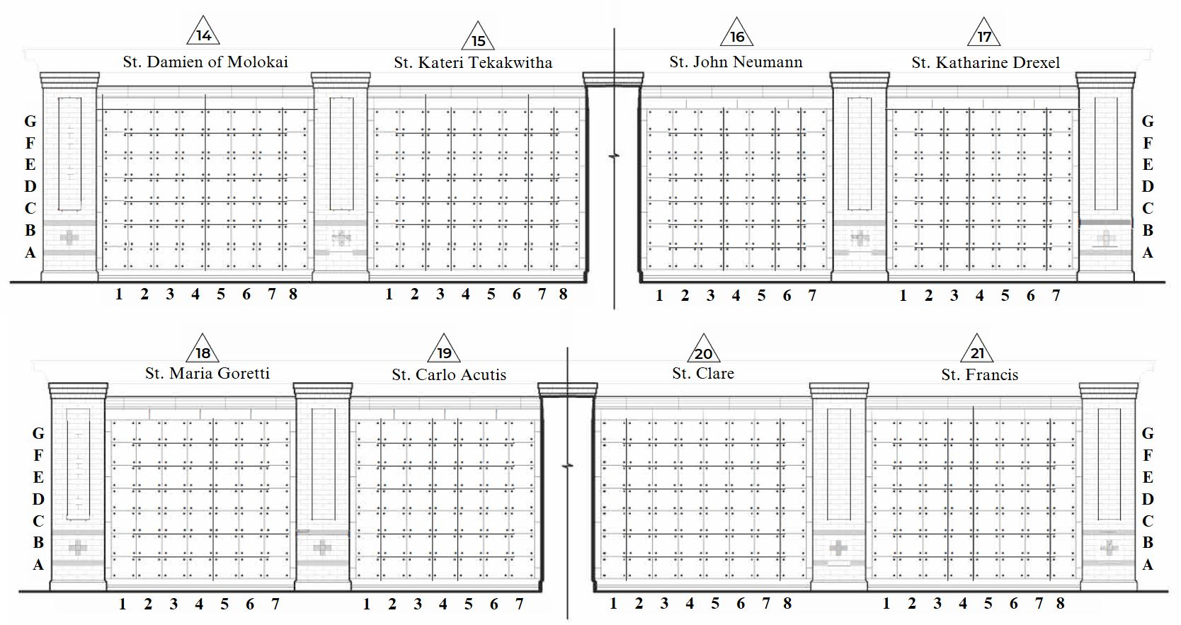
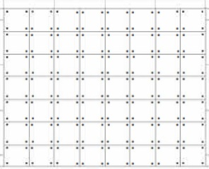
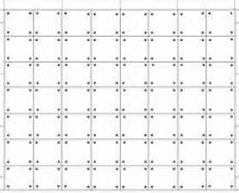
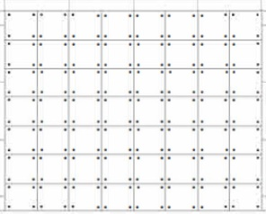
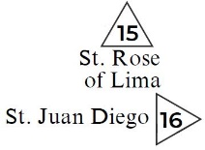
THE MOTHER SETON COLUMBARIUM

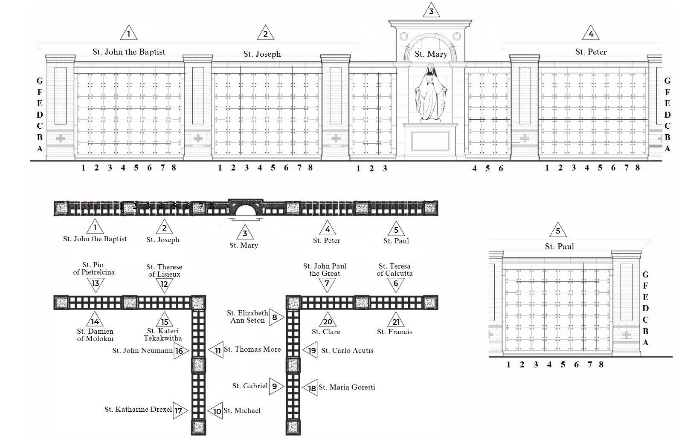
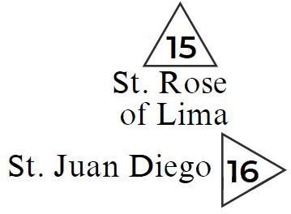
Panel Dedication Names

Floor Plan
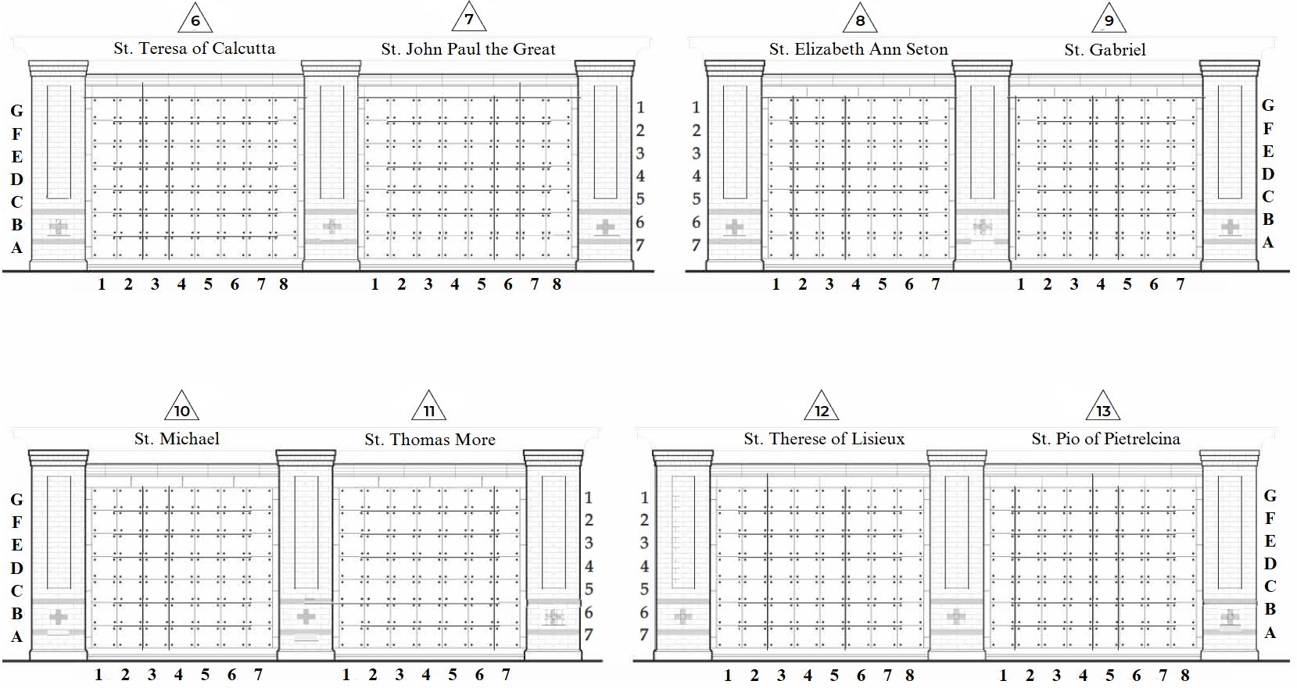
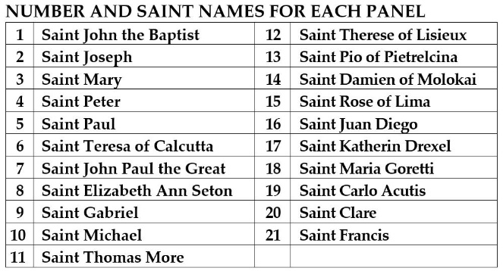
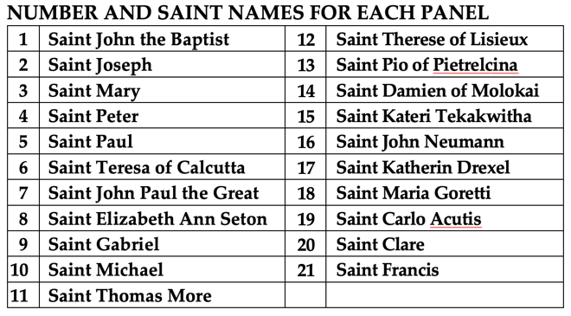
Selecting Niche: When filling out the Niche Commitment Form, please identify the Panel - Tier and Column niche you would like to reserve. For instance, if you want to reserve a niche in the Saint Joseph Panel “2” -Tier “E” - Column “5”, you will indicate NICHE 2-E5. See below for example reference.

2
The Saint Joseph Panel #2

Example reference:  - Panel Number: 2  - Tier (Row) Letter: E  - Column Number 5 | COLUMN
ROW | 1 | 2 | 3 | 4 | 5 | 6 | 7 | 8
G - $6,500 / $7,150 | 2-G1 | 2-G2 | 2-G3 | 2-G4 | 2-G5 | 2-G6 | 2-G7 | 2-G8
F - $7,500 / $8,250 | 2-F1 | 2-F2 | 2-F3 | 2-F4 | 2-F5 | 2-F6 | 2-F7 | 2-F8
E - $9,000 / $9,900 | 2-E1 | 2-E2 | 2-E3 | 2-E4 | 2-E5 | 2-E6 | 2-E7 | 2-E8
D - $9,000 / $9,900 | 2-D1 | 2-D2 | 2-D3 | 2-D4 | 2-D5 | 2-D6 | 2-D7 | 2-D8
C - $9,000 / $9,900 | 2-C1 | 2-C2 | 2-C3 | 2-C4 | 2-C5 | 2-C6 | 2-C7 | 2-C8
B - $7,500 / $8,250 | 2-B1 | 2-B2 | 2-B3 | 2-B4 | 2-B5 | 2-B6 | 2-B7 | 2-B8
A - $6,500 / $7,150 | 2-A1 | 2-A2 | 2-A3 | 2-A4 | 2-A5 | 2-A6 | 2-A7 | 2-A8

Questions. If you have any questions about these policies and procedures, please contact the parish at 494-4008 r.yates@setonlakeridge.org.

